Experiment 11

REST API for Playing Card Collection Using Express.js

Objective
Build a RESTful API using Express.js to manage a collection of playing cards. This task helps you understand routing, handling HTTP methods, and basic data manipulation in a Node.js backend environment.

Task Description
Create an Express.js server that provides API endpoints to manage a playing card collection. The API should allow you to perform operations such as listing all cards, adding a new card (with properties like suit and value), retrieving a specific card by ID, and deleting a card by ID. Store card data in an in-memory array for simplicity. The API should follow RESTful principles and handle different HTTP methods (GET, POST, DELETE) clearly, responding with appropriate JSON data.

Purpose of This Project
The goal is not really about cards themselves. It’s about learning how a backend API works using Express.js. The cards are just a simple example to practice.

What You’re Learning
1. Express.js basics – How to set up a server and use routes (GET, POST, DELETE).
2. RESTful API principles – Understanding GET, POST, DELETE (and later PUT for updates).
3. Handling JSON data – Sending and receiving JSON between client and server.
4. In-memory database – Storing data in an array, with the option to later use real databases like MongoDB.
5. Testing APIs – Using Postman or a browser to send requests and check responses.

Real-World Connection
Instead of cards, you could manage users, products, or bank accounts. This project is a training ground to understand how larger, real-world APIs work.

Step 4: Testing the API

1. Get all cards (initially empty)

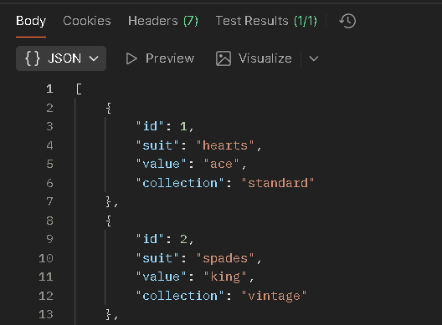
2. Add a new card
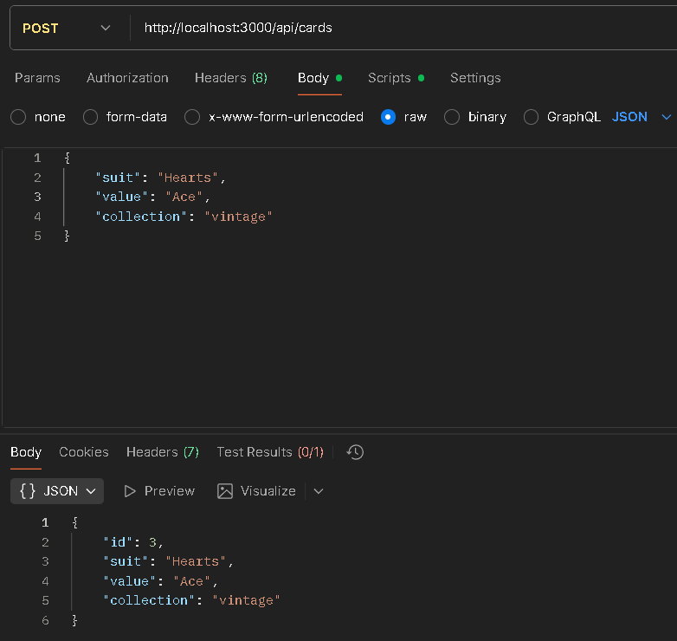

3. View all cards again
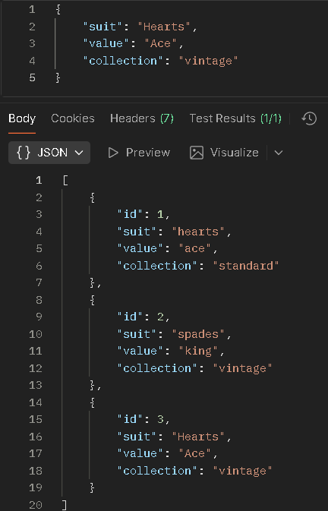
4. Get a specific card by ID
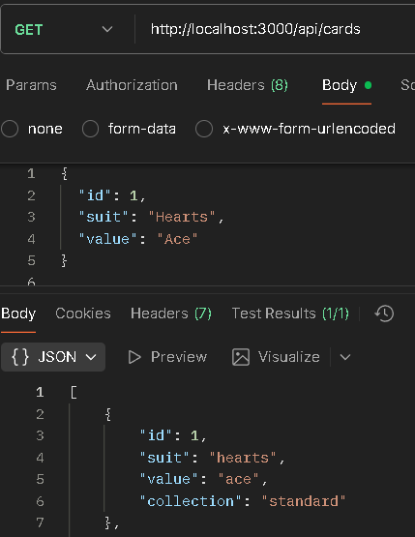
5. Delete a card by ID
